**BIS :** Business information system as a group of interrelated components that work collectively to carry out input, processing, output, storage and control actions in order to convert data into information products that can be used to support forecasting, planning, control, coordination, decision making and operational activities in an organization. **Principal Functional systems in a business**

The principal function system typically refers to the core systems or processes that are essential for the operation and management of the organization. These systems are fundamental to the business's activities and are often integrated to support various functions across departments. The principal function system may vary depending on the nature of the business, industry, and organizational structure.

Ex,

There are nine principal functional systems

* Purchasing
* Receiving
* Inventory
* Production
* Sales
* Distribution
* Billing
* Payment Collection
* Paying

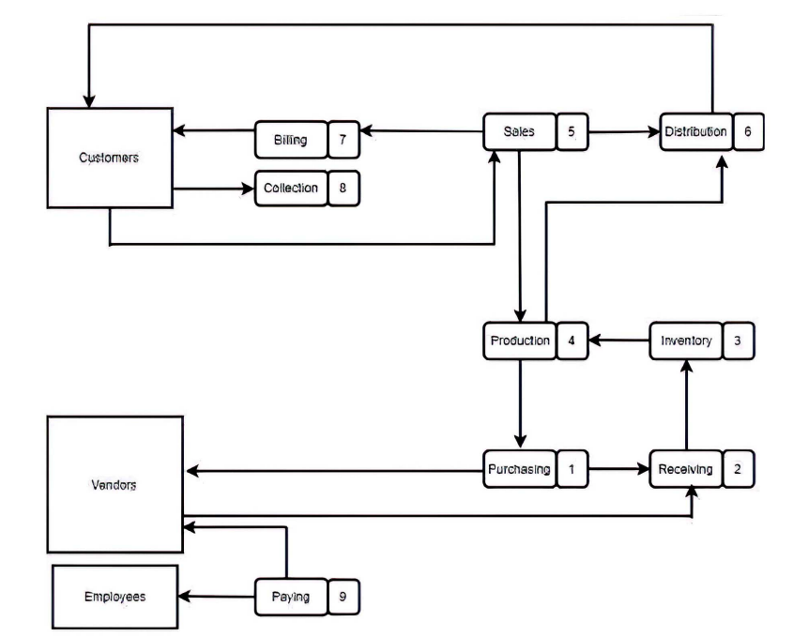

**Product flow** refers to the movement of physical goods or services through various stages of production, distribution, and consumption within a business or across its supply chain. It involves activities such as procurement, manufacturing, inventory management, transportation, and delivery. The goal of optimizing product flow is to minimize costs, reduce lead times, improve quality, and enhance customer

**Information flow** refers to the movement of data, knowledge, or instructions within and between different components of a business information system. It encompasses the transmission, processing, storage, and retrieval of information to support decision-making, communication, collaboration, and coordination among stakeholders. Information flow is crucial for maintaining visibility, control, and efficiency in business operations.

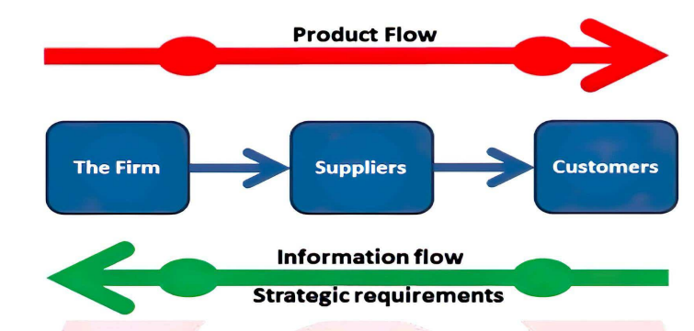

**Principal Document Associated with Information Flow**

The principal document associated with information flow in business information systems is typically referred to as the "Information Flow Diagram" or "Data Flow Diagram (DFD)."

A **DFD** is a graphical representation of the flow of data within a system. It illustrates how data moves from external entities into the system, gets processed, and then flows out to other external entities or storage locations. DFDs are commonly used during the analysis and design phases of system development to understand the information requirements, identify processes, and define data transformations.

**ERP :**

**Enterprise :** Company/Business, enterprise means group of people works together to achieve common goal with the help of resources

**Resource**: Anything which is used to run an enterprise/company. For example men, material, machines, money etc.

**Planning**: means optimum utilization of organizational resources. It also include what we want to achieve and how it will be achieved?

**What is ERP**

Enterprise resource planning is a software which provides infrastructural support for integration of day to day business activities with the aim of optimum utilization of enterprise (organizational) resources. No of departments works in an enterprise e.g. production, procurement, inventory management, HR, Finance, sales, marketing etc.

**ERP provide centralized database over which every department share their data.**

Every department has own database, and to get access to other department data it usually takes time due to which decisions are delayed, resources are not efficiently used. ERP solve the problem by providing a central database for all department.

**Advantages**

* Better resource utilization
* Fast decision making
* Cost reduction
* Better customer service
* Improved Efficiency
* Forecasting is easy

**Disadvantages:**

* It is expensive
* Difficulty in implementation, it takes time.
* Difficulty in integration.

**MIS (Management Information System) :**

A management information system (MIS) is a [computer](https://www.javatpoint.com/what-is-computer) system of hardware and software that acts as the foundation for an organization's operations. An MIS collects data from various online systems to support management decision-making, analyses the information, and reports data.

A management information system (MIS) is a computerized financial data database set up and designed to generate regular reports on operations for all levels of management within a firm**. The MIS often compares "actual" data to "planned" outcomes and results from the previous year to gauge progress toward goals.**

**Components of MIS**

* + People
  + Business procedures
  + Data
  + Hardware
  + Software

## Objective of MIS

## Data Capturing

## Processing of Data

## Storage of Information

## Retrieval of Information

## Dissemination of Information

## Characteristics of MIS

* + Management-oriented
  + According to requirements
  + Future-focused
  + Integrated
  + Accurate
  + Security
  + Common data flows
  + Long-term planning
  + Relevant relationship between subsystem planning
  + Central database

**Advantages of MIS**

* + Facilitates planning
  + Minimizes Information Overload
  + MIS Encourages Decentralization
  + **Brings Coordination**
  + **Makes Control Easier**

**Disadvantages of MIS**

* + expensive to set up
  + **Lack of Flexibility to Update Itself**
  + **Risk of fraud**
  + **Takes into Account only Qualitative Factors**
  + **Heavy reliance on technology**

**Development Process of MIS :**

* **Investigation**
* **Analysis**
* **Designing**
* **Testing**
* **Deployment**
* **Maintenance**

**DSS :**

**Components of DSS :**

1. Database management system.

2. Knowledge-base management system.

3. Model Management system.

4. User Interface Management System.

**Knowledge Base Management System:**

This component stores domain-specific knowledge, rules, and guidelines that aid in decision-making. It provides a repository for explicit knowledge that can be accessed and utilized by users.

**Model Management** : The Model Management System handles the management of mathematical, statistical, and analytical models used within the DSS. It includes functionalities for creating, storing, updating, and executing models for decision analysis.

**Characteristics of Decision Support System**

* + Handle Large Amount of Data From Different Sources
  + Provide Report & Presentation Flexibility
  + Offer Both Textual & Graphical Orientation
  + Support Drill-Down Analysis
  + Perform Complex, analysis
  + Goal Seeking Analysis
  + what-if analysis
  + Sensitive Analysis

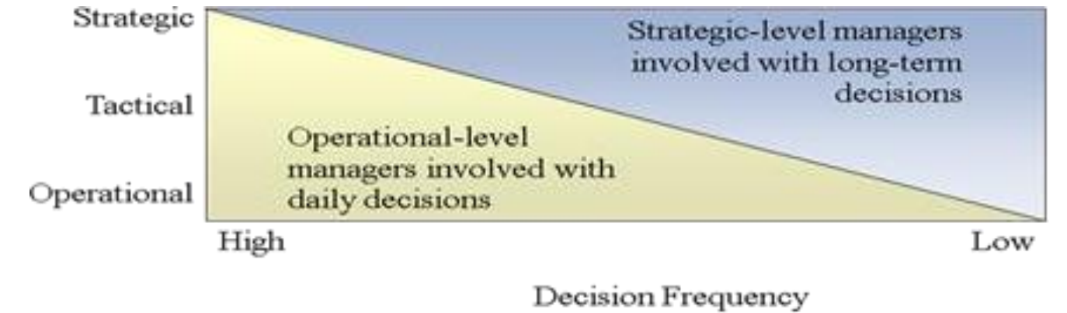

**Limitation of DSS:**

-small memories and limited storage capacities

-It is slow

-limited information sharing(unconnnectes)

**Unit – 4**

**TPS** : Transaction Processing System is type of system that facilitates the processing of business transactions. These transactions could involve sales, purchases, payments, reservations, or any other activity that generates or modifies data within an organization. Security is primary goal for every TPS.

**It collect, store, modify and retrieve the transactions.**

**Types of TPS :**

1. Batch Processing System
2. Real Time Processing System

**Purpose**: The primary purpose of a TPS is to efficiently process and record transactions in real-time or near-real-time. It ensures that transactions are accurately captured, processed, and stored in the organization's databases.

Example :

* Point of Sale Systems
* Payroll systems-processing employee's salary, loans management, etc.
* Stock Control systems-keeping track of inventory levels

**Batch processing systems**

In Batch processing system, all the transaction Collects as a group and then the entire batch processed at Once.

• Collects the transaction data as a group once.

• Has a time delay (hours, days)

• Low processing costs per transaction

• Batch processing is usually cyclic: daily, weekly, or monthly run cycle is established depending on the nature of the transactions

• Cheaper than on-line processing

• Easier to control than on-line processing

• Database is constantly out of date

• Used for pay cheques and when a time delay does not decrease the usefulness of the results.

**Transaction Processing Objectives:**

* Accuracy
* Timeliness
* Reliability
* Concurrency Control
* Data Integrity
* Recovery
* Scalability
* Security
* Auditability

**Transaction processing cycle OR Transaction Processing Activities**

* Data Collection
* Data Editing
* Data Correction
* Data Manipulation
* Data Storing
* Document Production and Reports

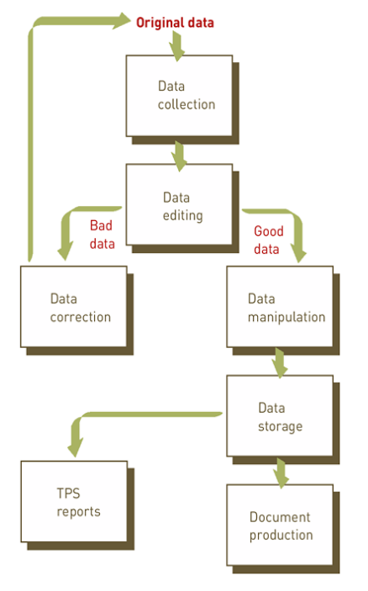

**Traditional Transaction Processing Applications :**

**ORDER PROCESSING SYSTEMS**